CS-330-T2831 2-5 Milestone Project Proposal

Jessica Megaro

November 6, 2022

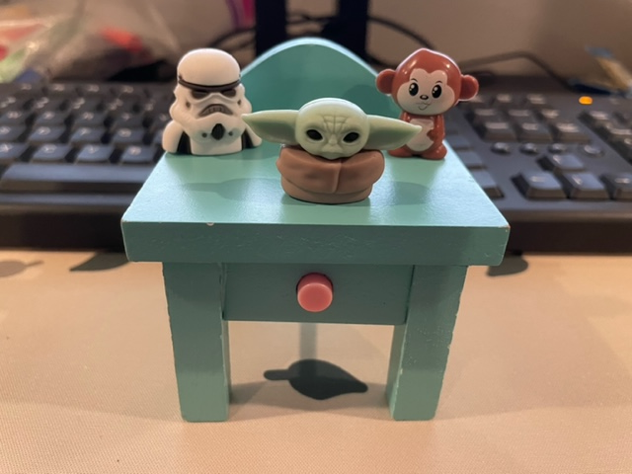

I have chosen to take my own photo to use for the project. We have a love for tiny toys in our home and I think it would be challenging to explore these shapes. I hope to create all 4 of the objects in 3D. For the dollhouse nightstand, right away I see how cubes and cylinders can come together to create the nightstand, and then maybe a sphere can form the back arched part. Grogu looks to be a combination of spheres, pyramids for ears, and a cylinder for his bottom half. The monkey might be deceptively hard to build, combining spheres and cylinders to make his head and body. And lastly, the storm trooper shape might prove too difficult to form into 3D. The storm trooper would require multiple small angles but might be easier to achieve with texturing and shading rather than additional geometry. Possibly a torus could come into play to form the rings around the storm trooper’s eyes. A plane will anchor the nightstand, but also a plane might be used as the top of the nightstand to use as a point to anchor all the bottoms of the characters. I believe these are good choices for my work because they are original and not a scene that can be found on endless internet sites. It’s not a simple choice, but I believe it is achievable.

After looking through the videos and surfing YouTube tutorials, I have learned the math in the shapes is the most challenging part to me. While trying to figure out how to move triangles for our last assignment, I noted that the (0,0) was in the center of the screen and not at the top left corner as the video had described. I had a hard time conceptualizing the X and Y axis and how it appeared in the OpenGL space. I am enjoying the work so far and look forward to the challenges in the project.